PROJECT REPORT ON

EduPulse – Tracking the Heartbeat of Academic Performance

FOR

NETLEAP TRAINING AND SOLUTIONS


Submitted by

- OM THOMBARE
- SAMEER BHOR
- RAMESH RATHOD

MATOSHRI COLLEGE OF ENGINEERING & RESEARCH CENTER

YEAR 2025-2026

DIRECTOR AND FOUNDER UNDER THE GUIDANCE OF

MRS.MRUNAL DAHALE MR.CHAITANYA DAHALE

CONTENTS

Chapter No | Title | Page No
1 | TITLE | 1
2 | ABSTRACT | 3
3 | ACKNOWLEDGEMENT | 4
4 | INTRODUCTION | 5
5 | MTHODOLOGY | 7
6 | RESULTS | 10
7 | FUTURE SCOPE | 11
8 | CONCLUSION | 12

ABSTRACT

The EduPulse project is designed to predict and analyze the final academic performance of students by integrating multiple dimensions of student data. Traditional evaluation systems are often limited to examination scores. EduPulse goes beyond grades to include:
- Behavioral attributes: study habits, free time, attendance
- Support factors: family support, school support
- Personal factors: health, failures, lifestyle choices
Methodology:
- Data Collection and Cleaning: Ensuring data integrity and consistency
- Exploratory Data Analysis (EDA): Identifying patterns and correlations
- Feature Engineering: Encoding categorical variables, scaling numerical features
- Regression Modeling: Applying Decision Tree and other regression models
- Evaluation and Interpretation: Using MAE, MSE, RMSE, R² score
Key Outcomes:
- Identify important predictors of academic success
- Provide interpretable model outputs for educators
- Enable data-driven interventions for at-risk students
This approach provides actionable insights, bridging the gap between educational assessment and predictive analytics.

ACKNOWLEDGEMENT

We would like to sincerely thank:
- Our Mentors: Mr. Chaitanya Joshi Sir, Ms. Sakshi More Mam, Mr. Chaitanya Dahale Sir, for their continuous guidance, expert feedback, and encouragement.
- Director of NetLeap: Mrs. Mrunali Abhishek Dahale, for providing the opportunity, resources, and professional learning environment.
- Peers and Colleagues: For assistance with data collection, preprocessing, visualization, and discussions on model selection.
The success of this project would not have been possible without their support and expertise.

INTRODUCTION

1. Background
Student academic performance depends on multiple interlinked factors:
- Previous Grades (G1, G2): Early indicators of future performance
- Behavioral Patterns: Study time, failures, free time allocation
- Support Systems: Family and school support mechanisms
- Health and Wellbeing: Physical and mental health impacts
Traditional grading systems fail to integrate these factors. EduPulse uses machine learning and educational data mining to uncover relationships, identify patterns, and predict outcomes.

2. Problem Statement
Educational challenges include:
- Delay in identifying low-performing students
- Lack of data-driven analysis of academic performance
- Inability to provide actionable insights for interventions
EduPulse addresses these gaps by:
- Leveraging data analytics for early detection
- Implementing predictive regression models
- Ensuring model interpretability for educators

3. Objectives
- Analyze academic and behavioral data for students
- Identify key influencing factors of final grades (G3)
- Build regression models for accurate prediction
- Interpret models to understand feature importance
- Provide actionable insights for intervention and support

4. Significance
- Data-Driven Decision Making: Supports evidence-based educational planning
- Early Intervention: Enables proactive identification of at-risk students
- Transparency: Interpretable models increase trust among educators
- Scalable: Framework can be adapted to multiple schools or datasets

METHODOLOGY

- System Overview
The EduPulse methodology is designed as a structured pipeline:
- Data Collection
- Data Preprocessing
- Exploratory Data Analysis (EDA)
- Feature Selection & Engineering
- Model Training
- Model Evaluation
- Model Interpretation

- Data Collection & Preprocessing
- Dataset: Student academic records including behavioral, personal, and academic features
- Preprocessing Steps:
  - Checked for null/missing values
  - Removed redundant columns
  - Corrected data types
  - Encoded categorical features using pd.get_dummies
  - Scaled numerical features
Outcome: Model-ready dataset (X: features, Y: target G3)

-Exploratory Data Analysis (EDA)
- Univariate Analysis: Histograms and boxplots to understand individual feature distributions
- Bivariate Analysis: Scatter plots and correlation matrices to analyze relationships with target
- Multivariate Analysis: Heatmaps to visualize feature interactions
Insights:
- G1 and G2 are the most significant predictors
- Study time, family support, and failures affect academic outcomes
- Skewness in features like free time and health requires normalization

- Feature Engineering & Selection
- Selected Features:
  - Academic: G1, G2
  - Behavioral: studytime, failures, freetime
  - Support: famsup, schoolsup
  - Health: health
- Feature Engineering Steps:
  - Dummy encoding categorical features
  - Standardization of numerical features
  - Avoided dummy variable trap using drop_first=True
Justification: Ensures relevant, interpretable, and model-ready inputs

- Model Training
- Target Variable: G3
- Model Type: Regression (continuous outcome)
- Chosen Model: Decision Tree Regressor
Reasons for Choice:
- Highly interpretable
- Visual decision paths
- Provides feature importance insights
Training Steps:
- Train-test split (80-20)
- Model fitting on training set
- Prediction on test set

- Model Evaluation
Regression metrics used:
- MAE (Mean Absolute Error): Average magnitude of errors
- MSE (Mean Squared Error): Penalizes large errors
- RMSE (Root Mean Squared Error): Error in original scale
- R² Score: Fraction of variance explained
Interpretation: High R² indicates strong model fit; low MAE/RMSE indicates prediction accuracy

- Model Interpretation
- Decision Tree output shows feature importance ranking
- Highlights strong predictors: G1, G2, studytime
- Explains why the model predicts a particular grade
Supports transparent intervention planning

RESULTS

Results Analysis
Feature | Importance
G2 | 0.947294
studytime | 0.018725
health | 0.007756
G1 | 0.007441
Walc | 0.007322
schoolsup | 0.005559
Freetime | 0.004151

Observations:
- Academic grades dominate prediction
- Behavioral and support factors influence marginally

Model is interpretable and actionable

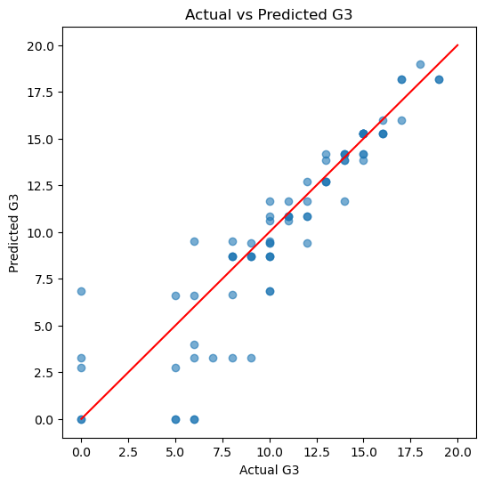
Fig1.predicated G3 vs actual G3

FUTURE SCOPE

- Real-time integration with student portals
- Ensemble models for higher accuracy (Random Forest, XGBoost)
- Automated dashboards for teachers and administrators
- Inclusion of attendance, participation, and co-curricular scores
- AI-driven personalized recommendations for students

CONCLUSION

The EduPulse project successfully demonstrates the application of machine learning techniques to predict students’ final academic performance in an accurate and reliable manner. By integrating academic records with behavioral, personal, and support-related factors, the system moves beyond traditional grade-based evaluation methods and provides a more holistic understanding of student performance.
One of the key strengths of EduPulse is its transparent and interpretable modeling approach. The use of Decision Tree Regression allows educators to clearly identify which factors—such as previous grades, study time, and academic failures—have the greatest influence on final outcomes. This interpretability ensures trust in the system and enables educators to make informed decisions based on clear evidence rather than assumptions.
Additionally, the project strongly supports early intervention programs by identifying students who are at risk of underperforming at an early stage. Timely identification enables institutions to implement corrective actions such as academic counseling, mentoring, or additional support, thereby improving overall student success rates.
Overall, EduPulse highlights how machine learning and educational data mining can significantly enhance educational decision-making. The project proves that data-driven approaches can improve academic planning, optimize resource allocation, and contribute to a more effective and student-centric education system.

REFERENCE

- UCI Machine Learning Repository – Student Performance Dataset
- Scikit-learn Documentation
- Pandas & NumPy Official Documentation
- Seaborn & Matplotlib Visualization Guides
- Romero, C., Ventura, S. (2007). Educational Data Mining: A Survey
- Baker, R. S. J. D., & Inventado, P. S. (2014). Educational Data Mining and Learning Analytics
- Research papers on Decision Tree Regression in Education

- Scikit-learn Documentation
- https://scikit-learn.org/stable/

- Pandas Documentation
- https://pandas.pydata.org/docs/

- NumPy Documentation
- https://numpy.org/doc/

- Kaggle – Student Performance Dataset
- https://www.kaggle.com/datasets/souradippal/student-performance-prediction

- GitHub
- https://github.com/

- OpenAI – ChatGPT
- https://openai.com/

